Switching Modes

* The layer 2 switches are used for transmitting the data on the data link layer, and it also performs error checking on transmitted and received frames.
* The layer 2 switches forward the packets with the help of MAC address.
* Different modes are used for forwarding the packets known as **Switching modes**.
* In **switching mode**, Different parts of a frame are recognized. The frame consists of several parts such as preamble, destination MAC address, source MAC address, user's data, FCS.

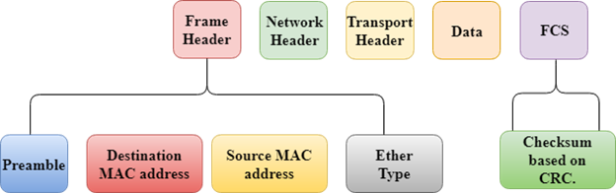

**There are three types of switching modes:**

* Store-and-forward
* Cut-through
* Fragment-free

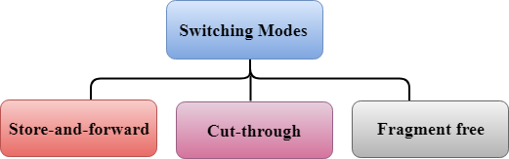

Store-and-forward

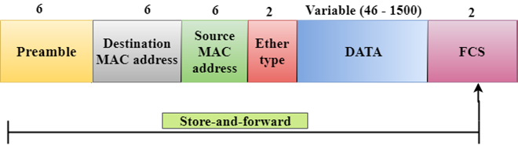

* Store-and-forward is a technique in which the intermediate nodes store the received frame and then check for errors before forwarding the packets to the next node.
* The layer 2 switch waits until the entire frame has received. On receiving the entire frame, switch store the frame into the switch buffer memory. This process is known as **storing the frame**.
* When the frame is stored, then the frame is checked for the errors. If any error found, the message is discarded otherwise the message is forwarded to the next node. This process is known as **forwarding the frame**.
* CRC (Cyclic Redundancy Check) technique is implemented that uses a number of bits to check for the errors on the received frame.
* The store-and-forward technique ensures a high level of security as the destination network will not be affected by the corrupted frames.
* Store-and-forward switches are highly reliable as it does not forward the collided frames.

Cut-through Switching

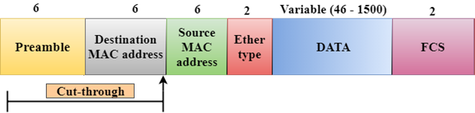

* Cut-through switching is a technique in which the switch forwards the packets after the destination address has been identified without waiting for the entire frame to be received.
* Once the frame is received, it checks the first six bytes of the frame following the preamble, the switch checks the destination in the switching table to determine the outgoing interface port, and forwards the frame to the destination.
* It has **low latency** rate as the switch does not wait for the entire frame to be received before sending the packets to the destination.
* It has no **error checking technique**. Therefore, the errors can be sent with or without errors to the receiver.
* A Cut-through switching technique has **low wait time** as it forwards the packets as soon as it identifies the destination MAC address.
* In this technique, collision is not detected, if frames have collided will also be forwarded.

Fragment-free Switching

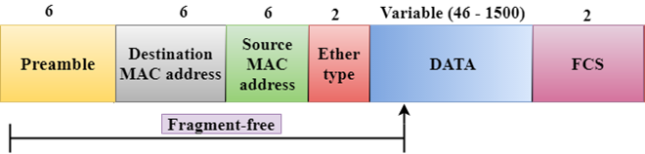

* A Fragment-free switching is an advanced technique of the Cut-through Switching.
* A Fragment-free switching is a technique that reads atleast 64 bytes of a frame before forwarding to the next node to provide the error-free transmission.
* It combines the speed of Cut-through Switching with the error checking functionality.
* This technique checks the 64 bytes of the ethernet frame where addressing information is available.
* A collision is detected within 64 bytes of the frame, the frames which are collided will not be forwarded further.

